A Project Report On

**“Social Media Platform”**

SUBMITTED IN THE PARTIAL

FULFILLMENT OF THE

REQUIREMENT FOR THE AWARD OF

THE DEGREE OF

**BACHELOR TECHNOLOGY**

In

Computer Science Engineering

Submitted by

**Dhiraj Kumar Gupta (12500120104)**

**Rohit Kumar Singh (12500120064)**

**Raushan Kumar (12500120164)**

Under the esteemed guidance of

**Mr. Soubhik Ghosh**

Asst. Professor

Department of CSE



Department of Computer Science and Engineering

**Bengal College of Engineering and Technology**

Durgapur, W.B.



Department of Computer Science and Technology

**Bengal College of Engineering and Technology**

Durgapur, W.B.

**CERTIFICATE OF APPROVAL**

The project entitled “Social Media Platform” submitted by Dhiraj Kumar Gupta (12500120104), Rohit Kumar Singh (12500120064) and Raushan Kumar (12500120164) under the guidance of Asst. Professor Mr. Soubhik Ghosh, is hereby approved as creditable study of engineering subject to warrant its acceptance as a pre-requisite to obtain the degree for which it has been submitted. It is understood that by this approval the undersigned don’t necessary endorse or approve any statement made, opinion or conclusion drawn therein but approve the project only for the purpose for what it is submitted.

Mr. Soubhik Ghosh Prof. Sk. Abdul Rahim

Asst. Prof. H.O.D.

Dept. of CSE Dept. of CSE



Department of Computer Science and Technology

**Bengal College of Engineering and Technology**

Durgapur, W.B.

**UDERTAKING**

We, Dhiraj Kumar Gupta (12500120104), Rohit Kumar Singh (12500120064), and Raushan Kumar (12500120164), B. Tech, 7th Semester (Computer Science and Engineering), hereby declare that our project entitled “Social Media Platform” is our own contribution. The work or ideas of other people which are utilized in this report has been properly acknowledged and mentioned in the reference. We undertake total responsibility if traces of plagiarism are found at any later stage.

Dhiraj Kumar Gupta

12500120104

Rohit Kumar Singh

12500120064

Raushan Kumar

12500120164

**ACKNOWLEDGEMENT**

We would like to thank our respected HOD Prof. Sk. Abdul Rahim for giving us the opportunity to work on the topic of our choice which is on “Social Media Platform”. Nonetheless, we would like to thank our project guide Asst. Prof. Mr. Soubhik Ghosh, whose valuable guidance has helped us to complete this project. His suggestions and instructions have served as the major contributor towards the complete of this project.

We would also like to express gratitude towards our friends and every person who helped in every person who helped in every little way by giving suggestion. We are also thankful to the college for providing necessary resources for the project.

**Table of Contents**

List of Figures

List of Tables

List of Abbreviations

ABSTRACT

1. INTRODUCTION
2. REVIEW OF LITERATURE
3. REPORT ON THE PRESENT INVESTIGATION
4. PROPOSED METHOD
5. DFD, ER DIAGRAM, ETC.
6. RESULT AND DISCUSSIONS
7. REFERENCES

List of Figures:

|  |  |  |
| --- | --- | --- |
| Fig. No. | Name of Figure | Page No. |
| 1 | Full Stack Java Developer Roadmap | 8 |
| 2 | Sign Up Page Front-end Design | 15 |
| 3 | Spring Boot Flow Architecture | 16 |
| 4 | Spring Boot Java project file | 16 |
| 5 | Login Page Front-end Design | 19 |
| 6 | Dashboard/Homepage Design | 20 |
| 7 | Social Media Flowchart | 23 |
| 8 | Spring MVC Workflow | 23 |
| 9 | Level-1 DFD | 24 |
| 10 | Level-2 DFD | 24 |
| 11 | ER Diagram | 25 |

List of Tables:

1. Review of Literature…………………………………………………..pg. 12-14

List of Abbreviations:

**Abbreviation** **Full-Form**

HTML HyperText Markup Language

CSS Cascading Style Sheets

MySQL My Structured Query language

API Application Programming Interface

MVC Model-View-Controller

TDD Test Driven Development

DFD Data Flow Diagram

ER Diagram Entity Relation Diagram

**ABSTARCT**

The use of social media websites and Smartphone applications with the internet connected to the device to keep a connection with family members and friends is known as social networking. A broader image of social network is that many big significantly based marketers are seeking to engage customers using social networking itself. Social networks have capabilities to entertain both the purposes, social purpose and a business purpose.

A growing number of people are interacting on the web to express and share their views and knowledge of products and brands through social networks. For consumers, some social networks’ profiles serve as a reference in their purchasing decision process, since these profiles are perceived as giving their personal unbiased opinion.

Obviously, now, the apparent image of social media appears like a misrepresentation.

In past few years, we have seen that innovation has brought us together from where we

started and social network nearly appears as though it is a totally extra ordinary technology.

**Chapter-1**

**INTRODUCTION**

1.1 Overview

Our social media platform is the replica of the Instagram app, where users can share images and video content and that can visible to the audience across the globe. This website is our pre-built social media website that helps people to communicate like in an Instagram like app. Our Social media platform project script has several unique features. Features can be added, deleted, and modified easily in the project. We provide a simple, easy & seamless user experience. And our website script is optimized to support numerous operations in real-time, with minimal delay.

Instagram app provides various features like sharing photos, videos, branding, influencing, snap shots, shopping and even many more things are present but our project is just based on sharing media and content to your personal network. This Social media website will be running in real-time Web. And Instagram Clone app is one of the best ideas for establishing a social network in which the customization will be done to make it different from the exact one.

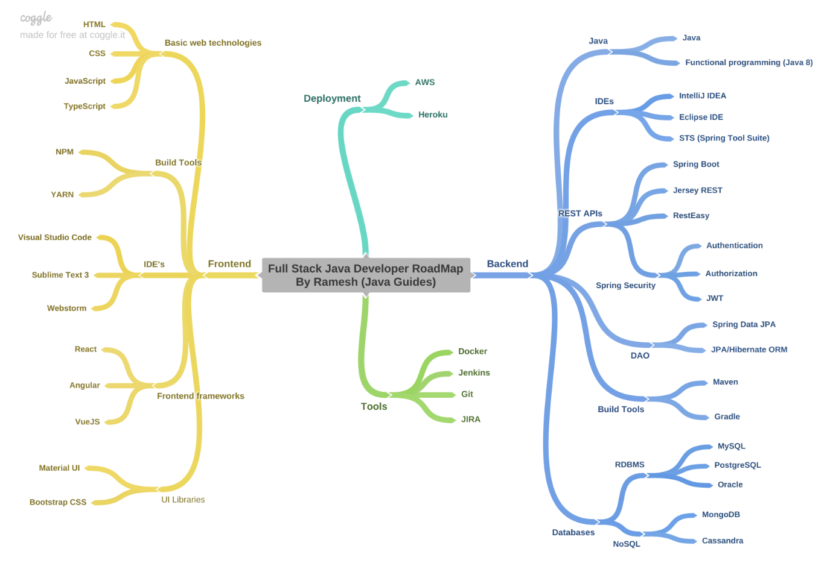1.2 Web Development Work Map Fig-1

1.3 Purpose and Scope of the Report

It was troublesome years back to speak with companions or family living in far off and faraway places, on account of innovation that isn't an issue any longer. Interpersonal interaction is becoming large in India and rest of the world with an ever-increasing number of clients going along with it consistently.

On these sorts of systems, we get together recognizable people or complete outsiders whom we share comparative enthusiasm with. On the off chance that the prior pattern was making affiliations and gatherings truly, the current age has confidence in making on the web networks and structures to talk about issues identified with different and assorted points.

The current framework is grown with the end goal that an enlisted client looks after his/her own profile and could likewise look through other comparable friend profiles over the application. An enlisted client can send companion demands over the site.

Scope:

* This framework gives clients to enroll their different kinds of social profiles,
* individual, proficient.
* The framework gives clients for transferring piece text data, pictures, or
* information documents to companions. Client may keep up the piece book
* whatever pieces he has send to clients.
* The framework gives client to transfer the photographs with the goal that client can keep up possess collection.
* This framework gives client to join the networks as indicated by their situation.
* This framework gives the client to keep up their companion rundown and client can refresh their companion list.

1.4 Planning and Design

* Defining Requirements: Discuss the essential features to include in the project, such as user profiles, image sharing, comments, likes, following/follower system, etc.
* System Architecture and Design: Outline the system architecture, database structure, and wireframes to plan the layout and functionalities of the website.

1.5 Domain Study

Today, social networking site use is a major activity for internet users from a wide range of demographic groups. Younger adults are especially avid adopters, but social networking continues to grow in popularity for older adults as well. Six out of ten internet users ages 50-64 are social networking site users, as are 41% of those ages 65 and older. Although online seniors are less likely than other age groups to use social networking sites, adoption rates for those 65 and older have tripled in the last four years.

The main types of social networking services are those that contain category places (such as former school year or classmates), means to connect with friends (usually with self-description pages), and a recommendation system linked to trust. Popular methods now combine many of Facebook, YouTube, LinkedIn, Instagram, Pinterest, Tumblr and Twitter widely used worldwide. Many of these early communities focused on bringing people together to interact with each other through chat rooms, and encouraged users to share personal information and ideas via personal web pages by providing easy-to-use publishing tools and free or inexpensive web space.

1.6 Objective

* To have attractive and Secure Login page to access
* Make new user account in more user friendly and proper validation of details
* Search people easily on entire network
* Send friend request to other users to make friends
* Add friends to your friend list accept request
* Creating a public profile having social, professional and personal information
* Ease of editing of profile anytime
* Chat with Online friends
* Upload and share images on network
* Add, Search and Shares videos of YouTube
* Send messages to other friends
* Reply directly to incoming user messages

**Chapter-2**

**LITERATURE SURVEY**

The Web-based social networking services make it possible to connect people who share interests and activities across political, economic, and geographic borders. Through e-mail and instant messaging, online communities are created where a gift economy and reciprocal altruism are encouraged through cooperation. Information is suited to a gift economy, as information is a non-rival good and can be gifted at practically no cost.

Facebook and other social networking tools are increasingly the object of scholarly research. Scholars in many fields have begun to investigate the impact of social- networking sites, investigating how such sites may play into issues of identity, privacy, social capital, youth culture, and education.

Several websites are beginning to tap into the power of the social networking model for philanthropy. Such models provide a means for connecting otherwise fragmented industries and small organizations without the resources to reach a broader audience with interested users. Social networks are providing a different way for individuals to communicate digitally. These communities of hypertexts allow for the sharing of information and ideas, an old concept placed in a digital environment.

In 2011, HCL Technologies conducted research that showed that 50% of British employers had banned the use of social networking sites/services during office hours.

|  |  |  |  |  |
| --- | --- | --- | --- | --- |
| Sl.No. | Author | Year | Title | Remarks |
| 1 | Stroud, Dick | 2008 | Social  networking  and how  Social  networking is  becoming a  set internet  based  application | This paper talks about how Social systems administration has immediately developed to get significant to all age gatherings and kinds of customer. The paper clarifies the essentials of interpersonal interaction, follows its beginnings and clarifies the purposes behind its ascent to conspicuousness. The paper thinks about how this application is probably going to create and closes by specifying the manner in which advertisers ought to respond. |
| 2 | Kai vom Brocke, Jan  Richter, Daniel  Riemer | 2011 | Social  Network  using Internet | The makers recognize four winning floods of research and review the key responsibilities to the field. The review reveals that the investigation field is partitioned and doesn't yet energize a general appreciation of the miracle. Explicitly research is particularly inclined towards certain customer social events. Further, implications for a corporate setting are discussed. In doing in that capacity, three settings of usage are isolated: Social framework areas (SNSs) for 1) choosing and capable business improvement, 2) relationship help in appropriated work settings, and 3) relationship with end customers. The makers talk about SNS prospects, repercussions of existing ISN research and future research openings. In summary, they attempt to add to an unrivaled understanding of the wonder of ISN and to making available the back-and-forth movement domain of ISN investigate for the more broad Enterprise 2.0 system. |
| 3 | Ganney, Paul S.  Pisharody, Sandhya  McDonagh, Ed | 2013 | Web development | The part starts with an assessment of different distinctive web facilitating procedures and stages, both programming and equipment. Numerous sorts are looked at, giving points of interest and disservices of all. Next, strategies for programming for the web are portrayed, beginning from a depiction of HTML, including usefulness by means of JavaScript, C++, and PHP. This is then extended to the assortment of information. HTML structures are portrayed, both as hard-coded and created by means of C++. Further venture into dynamic substance is thought of, both produced code and auto invigorating pages, and instances of database use are given. The last piece of the section portrays security especially as applied to web applications, through procedures for get to restriction (both server and customer side). The section closes with an assessment of open and private key encryption and computerized marks. |
| 5 | Burd, Barry | 2014 | Beginning  Programming  with Java for  Dummies | Starting Coding with Java, is a far-reaching manual for learning one of the most famous programming dialects around the world. This book covers essential advancement ideas and methods through a Java focal point. You'll realize what goes into a program, how to assemble the pieces, how to manage difficulties, and how to make it work. The new Fourth Edition has been refreshed to line up with Java 8, and incorporates new alternatives for the most recent devices and strategies. Java is the prevalent language used to program Android and cloud applications, and its prominence is flooding as application request rises. Regardless of whether you're simply tooling near, or setting out on a profession is an incredible spot to begin. Bit by bit guidance, simple to-understand language, and snappy route make this book the ideal asset for new software engineers. You'll start with the rudiments before moving into code, with straightforward, yet itemized clarifications at all times. |

**Chapter-3**

**REPORT ON PRESENT INVESTIGATION**

3.1 System Description

* Hardware Spec.-
* Processor Name: Dual Core
* Processor Speed: 3.2GHz
* RAM: 12GB
* SSD Capacity: 256GB
* Display Monitor- 15.6inch Laptop Screen
* Keyboard & Mouse: Wireless

3.2 Technologies Used

* Java- programming language
* HTML- markup language
* CSS- style sheet language
* JavaScript- programming language
* VS Code- IDE
* Docker Desktop- software platform
* MySQL Workbench- visual database design tool
* Postman API- API platform

3.3 Process Description

Beginning with User Sign Up and Authentication:

* Inputs: User Information.
* Registration on Website.
* Authentication from website.

Designing:

Display Structure-

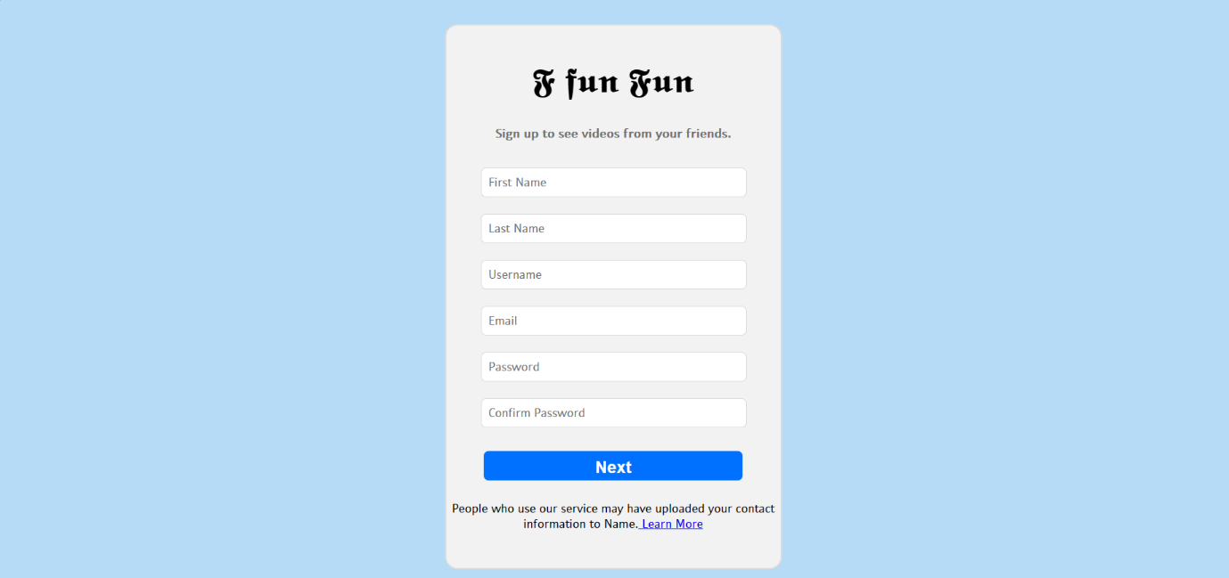Fig-2

Backend Flow:

The Spring Boot is built on top of the core Spring framework. It is a simplified and automated version of the spring framework. The spring boot follows a layered architecture in which each layer communicates to other layers. Spring Boot makes it easy to create stand-alone, production-grade Spring based application that you can “Just Run”.

Following steps are involved in Spring MVC workflow-

1. The request will be received by Front Controller i.e., DispatcherServlet.
2. DispatcherServlet will pass this request to HandlerMapping. HandlerMapping will find suitable Controller for the request
3. HandlerMapping will send the details of the controller to DispatcherServlet.
4. DispatcherServlet will call the Controller identified by HandlerMapping. The Controller will process the request by calling appropriate method and prepare the data. It may call some business logic or directly retrieve data from the database.
5. The Controller will send ModelAndView(Model data and view name) to DispatcherServlet.
6. Once DispatcherServlet receives ModelAndView object, it will pass it to ViewResolver to find appropriate View.
7. ViewResolver will identify the view and send it back to DispatcherServlet.
8. DispatcherServlet will call appropriate View identified by ViewResolver.
9. The View will create Response in form of HTML and send it to DispatcherServlet.
10. 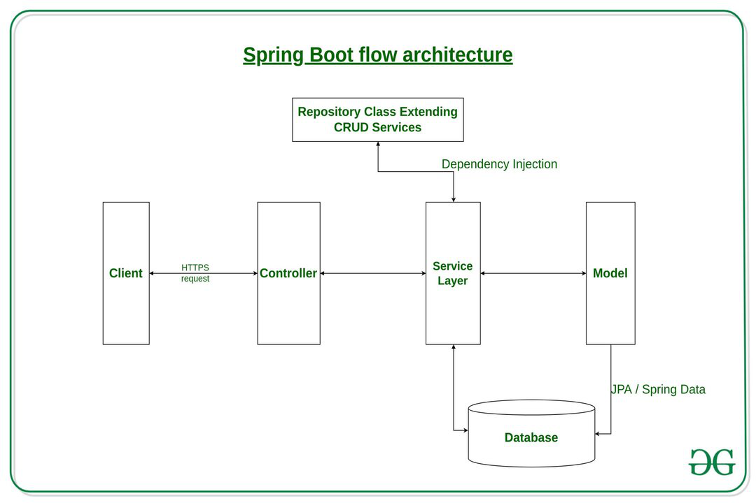DispatcherServlet will send the response to the browser. The browser will render the html code and display it to end user.

Fig-3

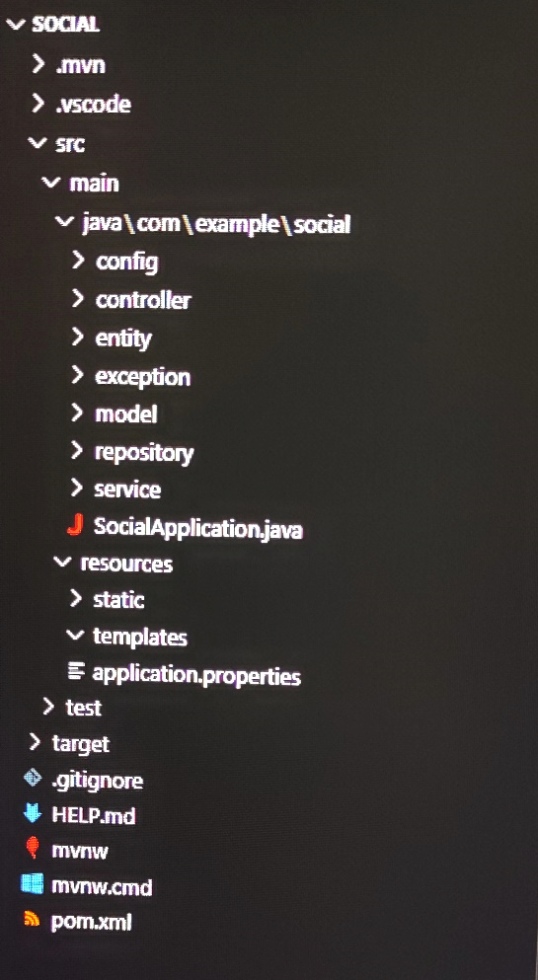

Fig-4

The User Controller Class is as follow:

package com.example.social.controller;

import java.io.IOException;

import java.util.List;

import org.springframework.beans.factory.annotation.Autowired;

import org.springframework.http.HttpStatus;

import org.springframework.http.ResponseEntity;

import org.springframework.web.bind.annotation.DeleteMapping;

import org.springframework.web.bind.annotation.GetMapping;

import org.springframework.web.bind.annotation.PathVariable;

import org.springframework.web.bind.annotation.PostMapping;

import org.springframework.web.bind.annotation.PutMapping;

import org.springframework.web.bind.annotation.RequestBody;

import org.springframework.web.bind.annotation.RequestMapping;

import org.springframework.web.bind.annotation.RequestParam;

import org.springframework.web.bind.annotation.RestController;

import org.springframework.web.multipart.MultipartFile;

import com.example.social.entity.User;

import com.example.social.service.UserService;

@RestController

@RequestMapping("/user")

public class UserContoller {

    @Autowired

    UserService service;

    @PostMapping("")

    public ResponseEntity<String> createUser(@RequestBody User user){

        return new ResponseEntity<String>(service.createUser(user), HttpStatus.CREATED);

    }

    @PutMapping("/{id}")

    public ResponseEntity<String> createUserWithPic(@PathVariable int id, @RequestParam("file") MultipartFile file) throws IOException{

        return new ResponseEntity<String>(service.uploadPic(id, file), HttpStatus.CREATED);

    }

    @GetMapping("/{id}")

    public ResponseEntity<User> getUser(@PathVariable int id){

        return new ResponseEntity<User>(service.getUser(id), HttpStatus.OK);

    }

    @PutMapping("")

    public ResponseEntity<User> updateUser(@RequestBody User user){

        return new ResponseEntity<User>(service.updateUser(user), HttpStatus.OK);

    }

    @DeleteMapping("/{id}")

    public ResponseEntity<String> deleteUser(@PathVariable int id){

        return new ResponseEntity<String>(service.deleteUser(id), HttpStatus.NO_CONTENT);

    }

    @GetMapping("/addFriend/{uid}/{fid}")

    public ResponseEntity<Boolean> addFriend(@PathVariable("uid") int user_id, @PathVariable("fid") int friend_id){

        service.addFriend(user_id, friend_id);

        return new ResponseEntity<Boolean>(true, HttpStatus.OK);

    }

    @GetMapping("/getFriendList/{id}")

    public ResponseEntity<List<User>> getFriendList(@PathVariable int id){

        return new ResponseEntity<List<User>>(service.getFriendList(id), HttpStatus.OK);

    }

}

After User Sign Up and Authentication, User can Login:

* Inputs: User email and password.
* Get data from Database.
* Authentication from website.

Designing:

Display Structure-

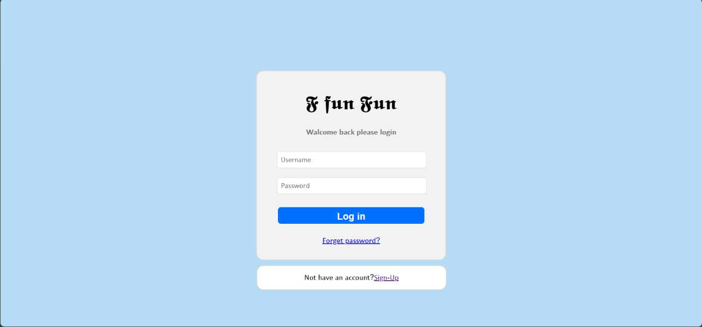Fig-5

User Repository Class:

package com.example.social.repository;

import org.springframework.data.repository.CrudRepository;

import org.springframework.stereotype.Repository;

import com.example.social.entity.User;

@Repository

public interface UserRepository extends CrudRepository<User, Integer> {

}

Landing Page/ Dashboard/ Homepage after login:

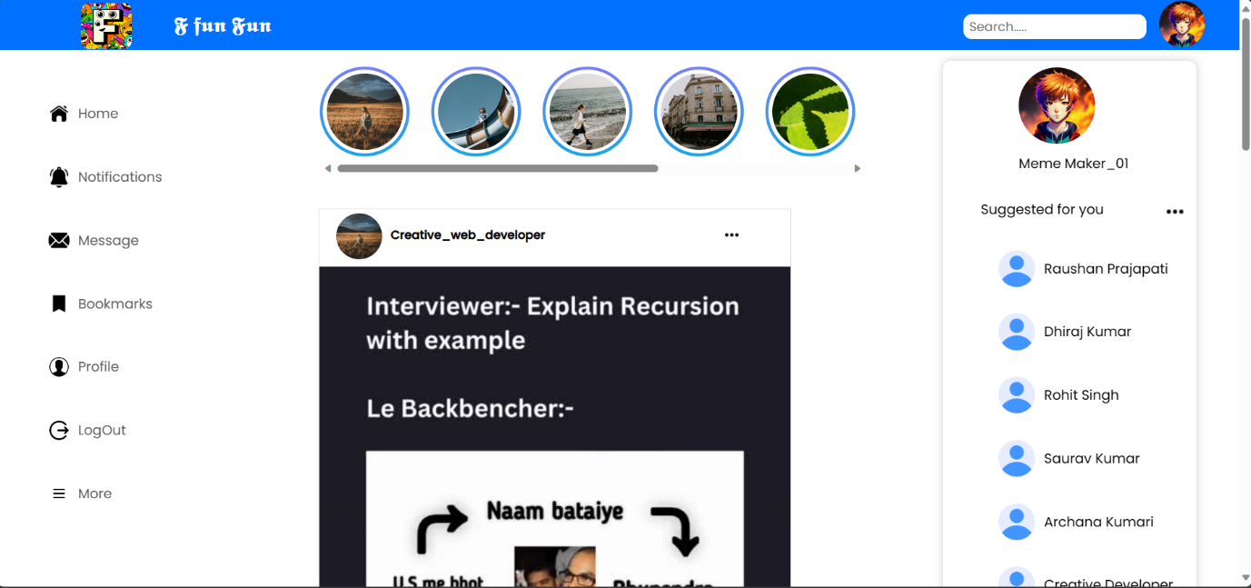Design:

Fig-6

Connecting to MySQL DataBase Dockers container:

spring.jpa.hibernate.ddl-auto=update

spring.jpa.properties.hibernate.dialect: org.hibernate.dialect.MySQL8Dialect

spring.datasource.url = jdbc:mysql://localhost:3306/social

spring.datasource.username=root

spring.datasource.password=p@ssword

spring.datasource.driver-class-name=com.mysql.cj.jdbc.Driver

spring.jpa.show-sql:true

**Chapter-4**

**PROPOSED METHODS**

1. Integration with Social Media APIs:

- Leveraging Spring Boot's capabilities, we'll develop a system to integrate with various social media platform APIs such as Facebook, Twitter, Instagram, etc. This integration will allow seamless extraction and management of data.

2. Data Retrieval Modules Development:

- Utilizing Spring's dependency injection and MVC architecture, we'll create modules specifically designed for data collection. These modules will fetch crucial metrics like user engagement, post analytics, demographics, etc., from the respective social media APIs.

3. Scheduled Data Updates:

- Implementing Spring's scheduling capabilities, we'll set up scheduled tasks to periodically retrieve and update data. This approach ensures that the analysis is based on the most recent information available, facilitating real-time insights.

4. Security Implementation with Spring Security:

- Employing Spring Security features, our system will prioritize the secure handling of sensitive user data obtained from social media platforms. This includes implementing authentication, authorization, and encryption to ensure data privacy and compliance with security standards.

5. Best Practices Adherence:

- Throughout the development lifecycle, we'll adhere to industry best practices such as test-driven development (TDD), ensuring the creation of robust, reliable, and maintainable code. Additionally, employing continuous integration/delivery (CI/CD) practices will streamline development processes, enhancing the efficiency of the system.

6. Scalability and Performance Optimization:

- Considering Spring Boot's scalability features, we'll design the system to handle large volumes of data efficiently. Implementing caching mechanisms and optimizing database interactions will ensure optimal performance even with increased data loads.

7. Logging and Monitoring:

- Implementing logging mechanisms using Spring Boot's capabilities will enable effective tracking of system activities and potential issues. Additionally, integrating monitoring tools for system health checks will facilitate timely identification and resolution of any performance bottlenecks.

8. Documentation and Maintenance:

- Thorough documentation of code and system architecture will aid in understanding and maintaining the developed system. This documentation will ensure that future updates or modifications can be executed seamlessly.

9. User Interface Development (Optional):

- Optionally, the development of a user interface using Spring Boot's support for frontend frameworks like Thymeleaf or React can be considered. This interface can provide a user-friendly dashboard to visualize and interact with the collected social media data.

By combining these methodologies within the Spring Boot framework, we aim to create a robust and efficient system for analyzing social media data, offering valuable insights for businesses and marketers.

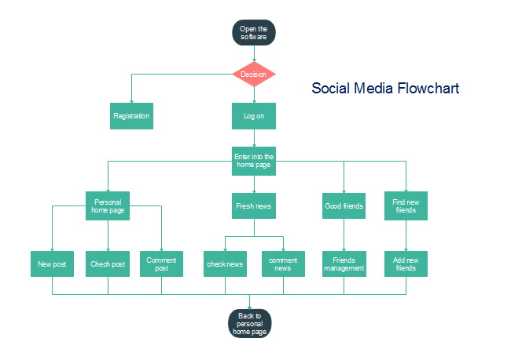FLOWCHART:

Fig-7

**Chapter-5**

**DFD, ER DIAGRAM**

Spring MVC Workflow:

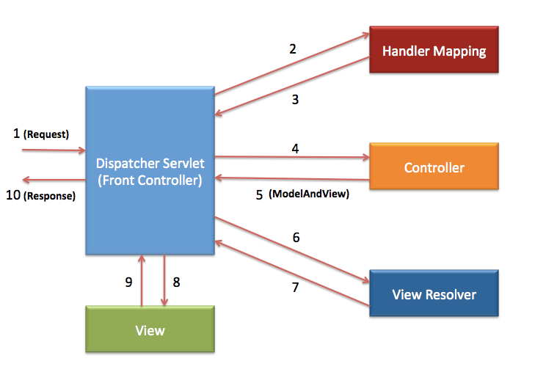Fig-8

Level-1 DFD:

Fig-9

Level-2 DFD:

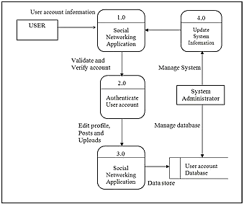

Fig-10

ER Diagram:

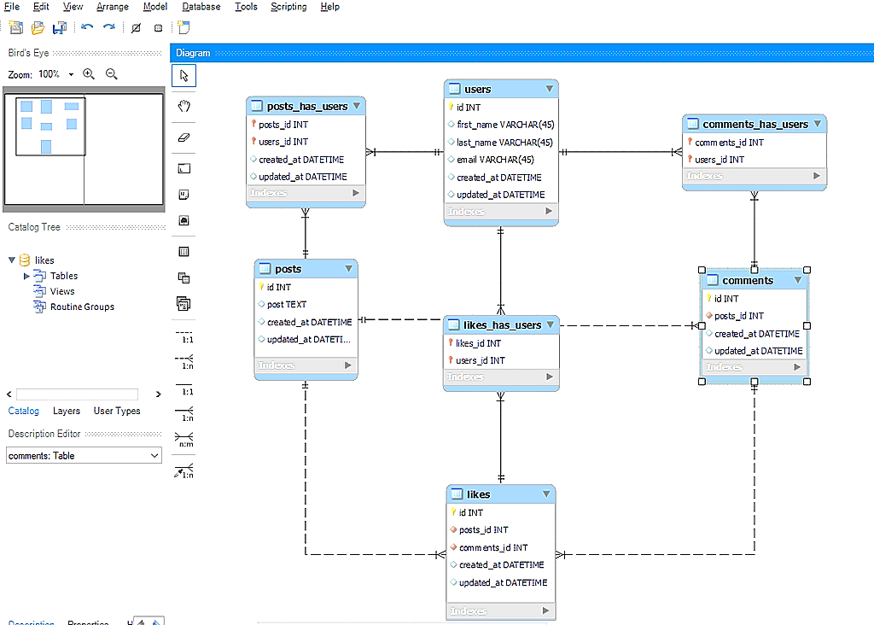

Fig-11

**Chapter- 6**

**RESULT AND DISCUSSION**

Results:

1. Feature Implementation: Successfully integrated core functionalities (authentication, profiles, posting, commenting, following users).

2. Performance: System exhibited good performance with acceptable response times, ensuring a positive user experience.

3. User Engagement: Positive feedback on user interface; interactive features boosted user engagement.

Discussions:

1. Challenges: Faced hurdles in optimizing database queries and real-time notifications.

2. Future Enhancements: Focus on scalability via caching mechanisms, advanced content algorithms, and refined notification systems.

3. Security Measures: Implemented industry-standard security practices to safeguard user data.

Conclusion:

The Spring Boot-based social media site met primary objectives by delivering essential functionalities and encouraging user engagement. Future efforts will target scalability, enhanced user experience, and continuous security updates.

**Chapter-6**

**REFERENCES**

1. Thorpe, I 2011, ‘8 Uses for social media in aid work’, viewed 23 September 2011, <http://kmonadollaraday.wordpress.com/2011/03/14/8-uses-for-social-media-in-aid-work/>
2. Soltren, J 2005, Facebook: Threats to Privacy, MIT, Massachusetts.
3. Castells, M 2009, Communication Power, Oxford University Press, Oxford.
4. Stack Over-flow --> <https://stackoverflow.com/>
5. Geeks for Geeks --> <https://www.geeksforgeeks.org/>
6. Java2Blog --> <https://java2blog.com/>
7. Javapoint --><https://www.javatpoint.com/>
8. Git Hub Repositories --> <https://github.com/>